 

# National University of Computer and Emerging Sciences



# **Design and Analysis of Algorithm**

# **Fall 2022**

# **PROJECT REPORT**

# Group Members

Kiran 19K-1487 (CS-5F)

Pawan 19K-0250 (CS-5B)

Irtisam 19K-1488 (CS-5F)

# FAST School of Computing

**National University of Computer and Emerging Sciences**

# November, 2023

1

# Abstract:

## The challenge lies in creating a graphical representation of the sorting procedures. The objective is to create a programme that displays all ten sorting algorithms on an input file graphically and generates the necessary steps to produce a sorted output.

# Introduction

It is possible to organize the items on a list using an algorithm. Numbers, both in increasing and decreasing order, and words are the two most common types of ordering systems. Sorting efficiently is essential to maximize the performance of other algorithms that depend on ordered lists of input data. Sorting also aids in canonicalizing data and producing human-intelligible output.

* **Complexity of Sorting Algorithms**

The time complexity and space complexity of a sorting algorithm are two key metrics for evaluating the algorithm's effectiveness.

* **Time Complexity:** Time complexity describes how long it takes to run an algorithm relative to the size of the input. Many different interpretations are possible such as: Big-O notation (O),Omega notation (Ω) and Theta notation (Θ)
* **Space Complexity:** The term "space complexity" is used to describe the total amount of memory that an algorithm requires to complete its execution. Input and secondary storage are included. An algorithm's auxiliary memory is the data storage space it employs beyond the parameters provided to it by the user. Consideration of auxiliary memory is standard practice when determining the space complexity of an algorithm.

## **Program Design:**

## JavaScript was used throughout the development of this project; CSS was utilized for the layout and output of the final product. This system is described as follows: first, a user interface prompts the user to select the input file to be sorted; then, the algorithm converts the input file into an array to generate the bar for sorting; after the sorting bars have been generated, the user chooses the algorithm and the speed at which the sorting would occur; and finally, the sorting process is visualized as it progresses.

## **EXPERIMENTAL SETUP**

Step 1: The user interface loads, and the user is given the option to select the text file that contains the numerical values.

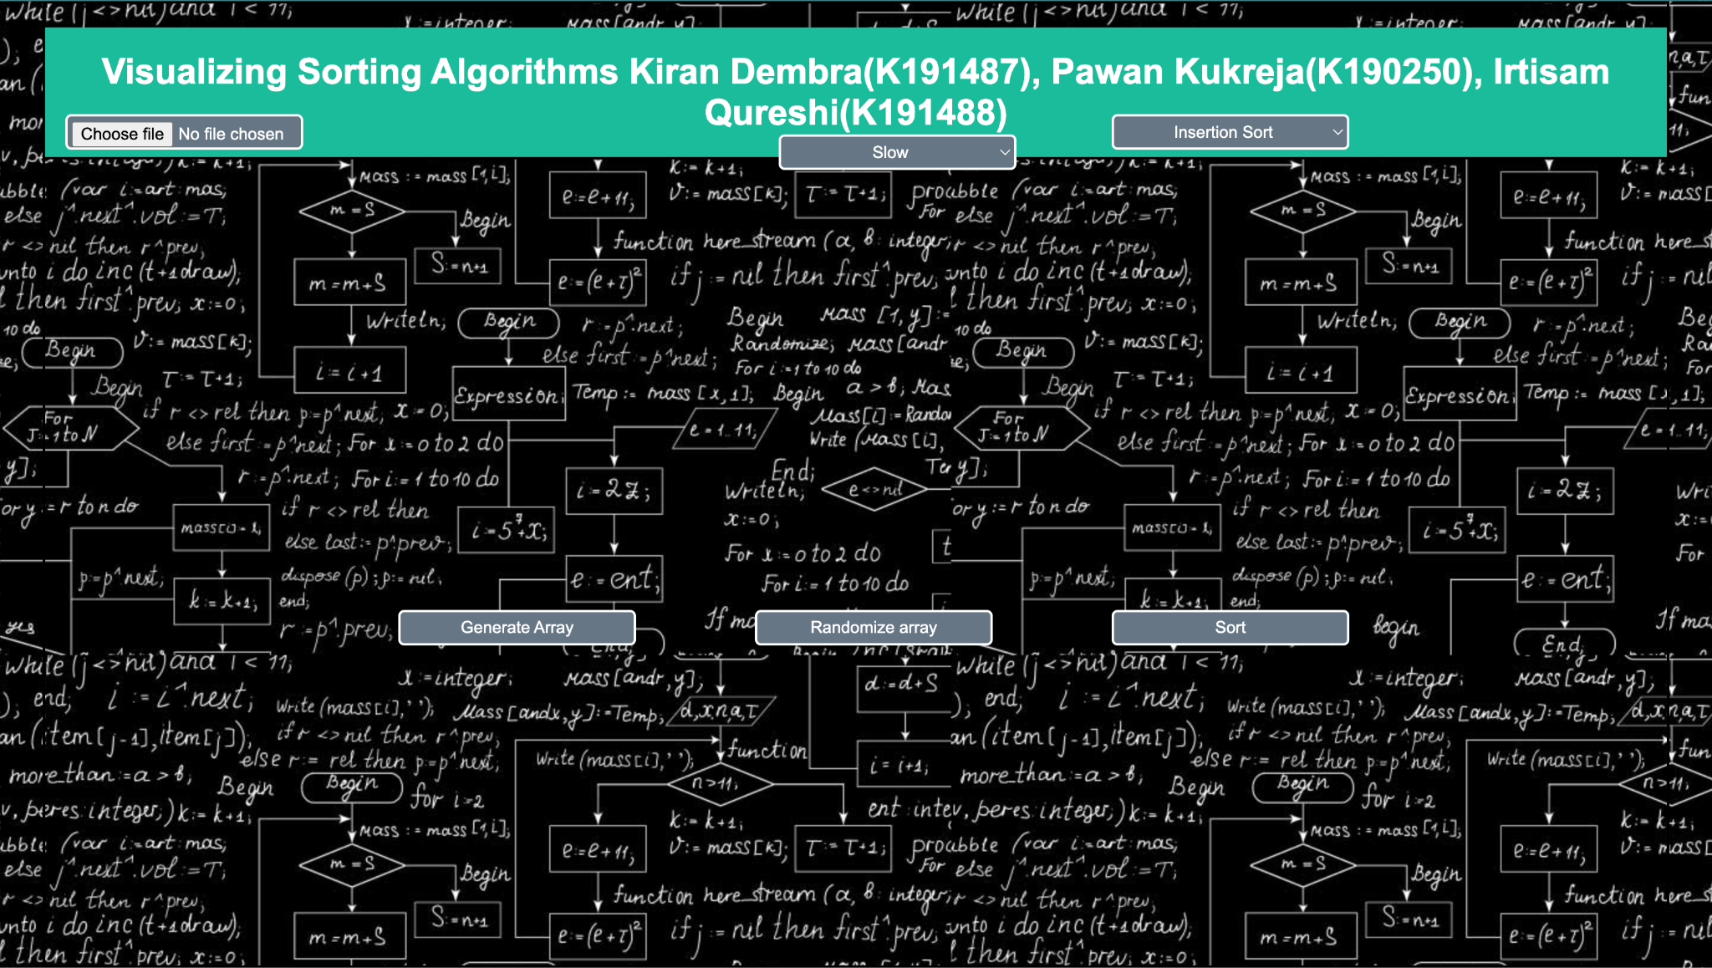

Step 2: User selects the text file that contains the numbers to be sorted

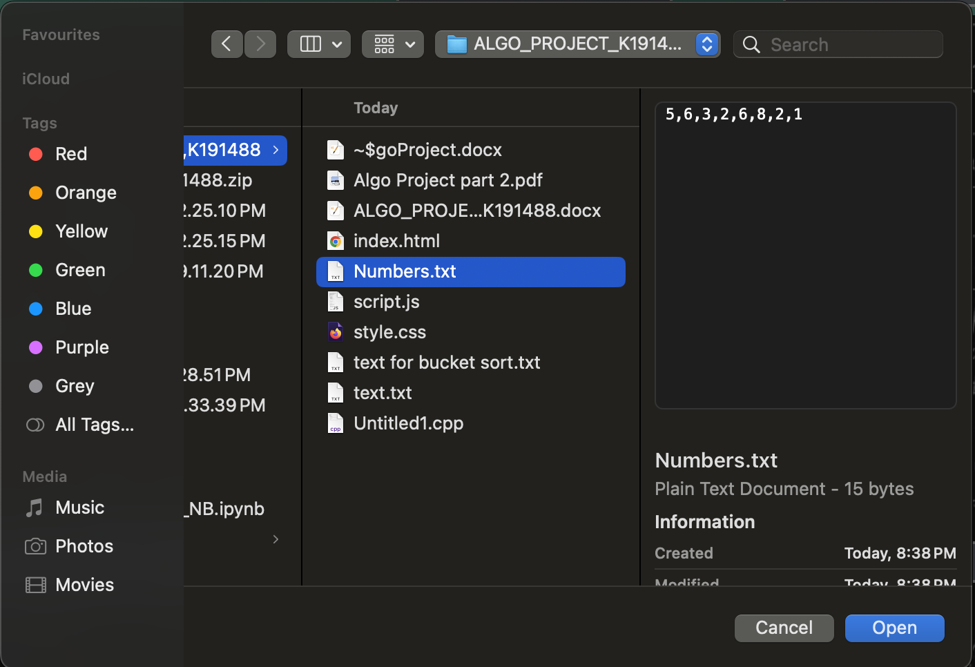

Step 3: User generates the Array

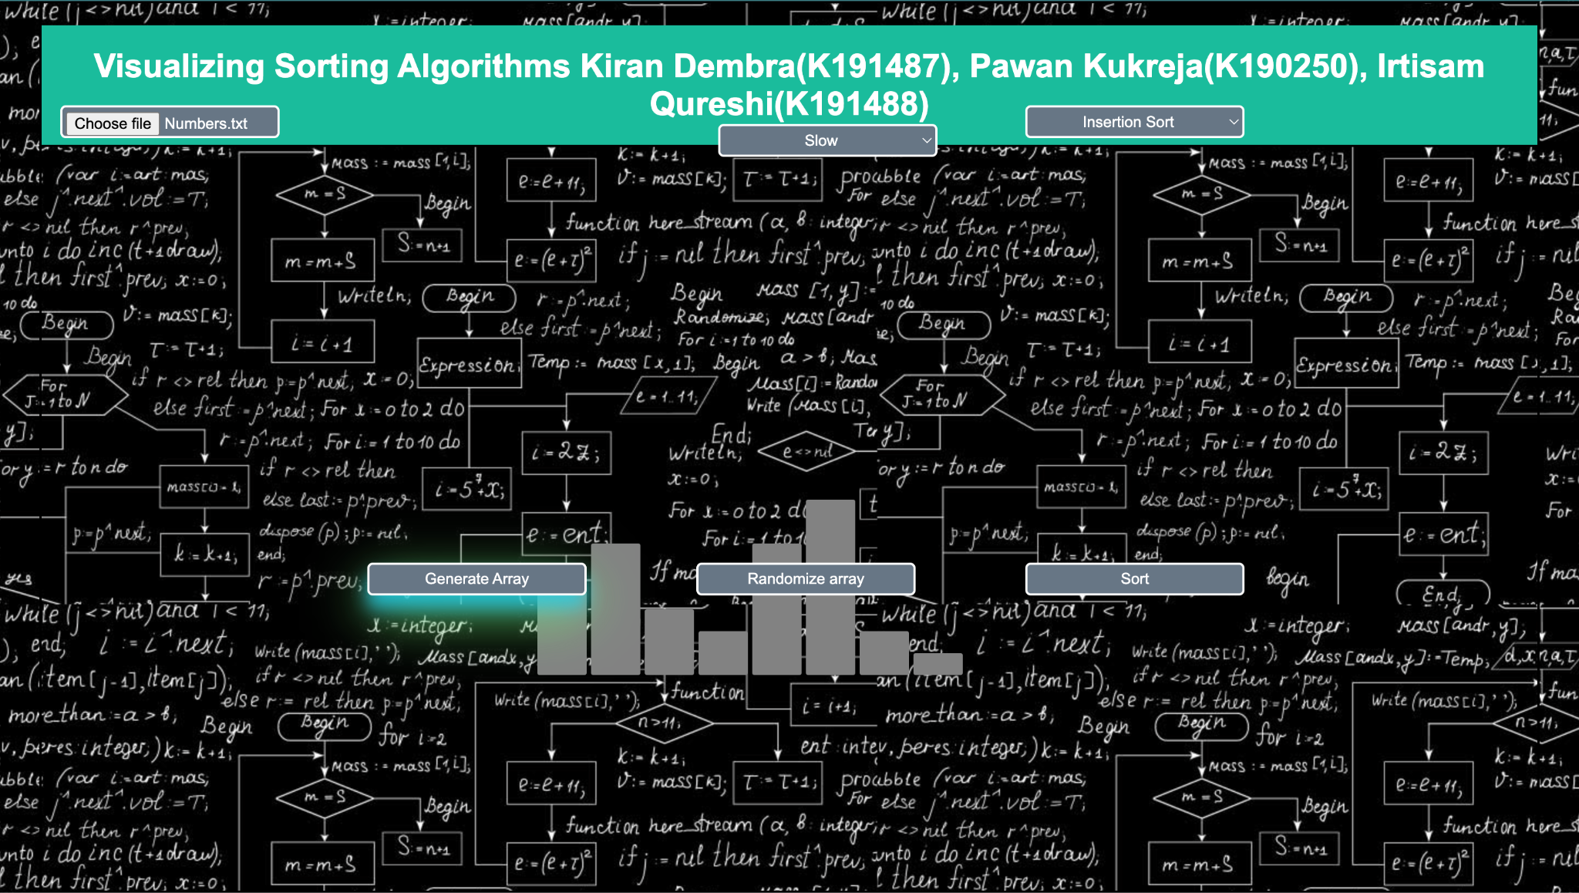

Step 4: User selects the speed either Fast or Slow

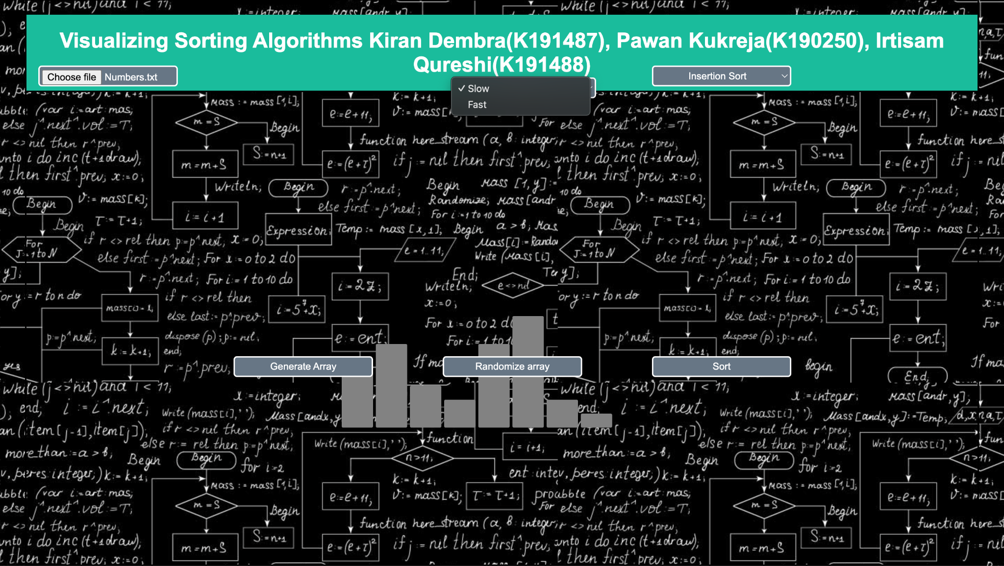

Step 5: User Select the Sorting Algorithm out of the 10 Possibilities

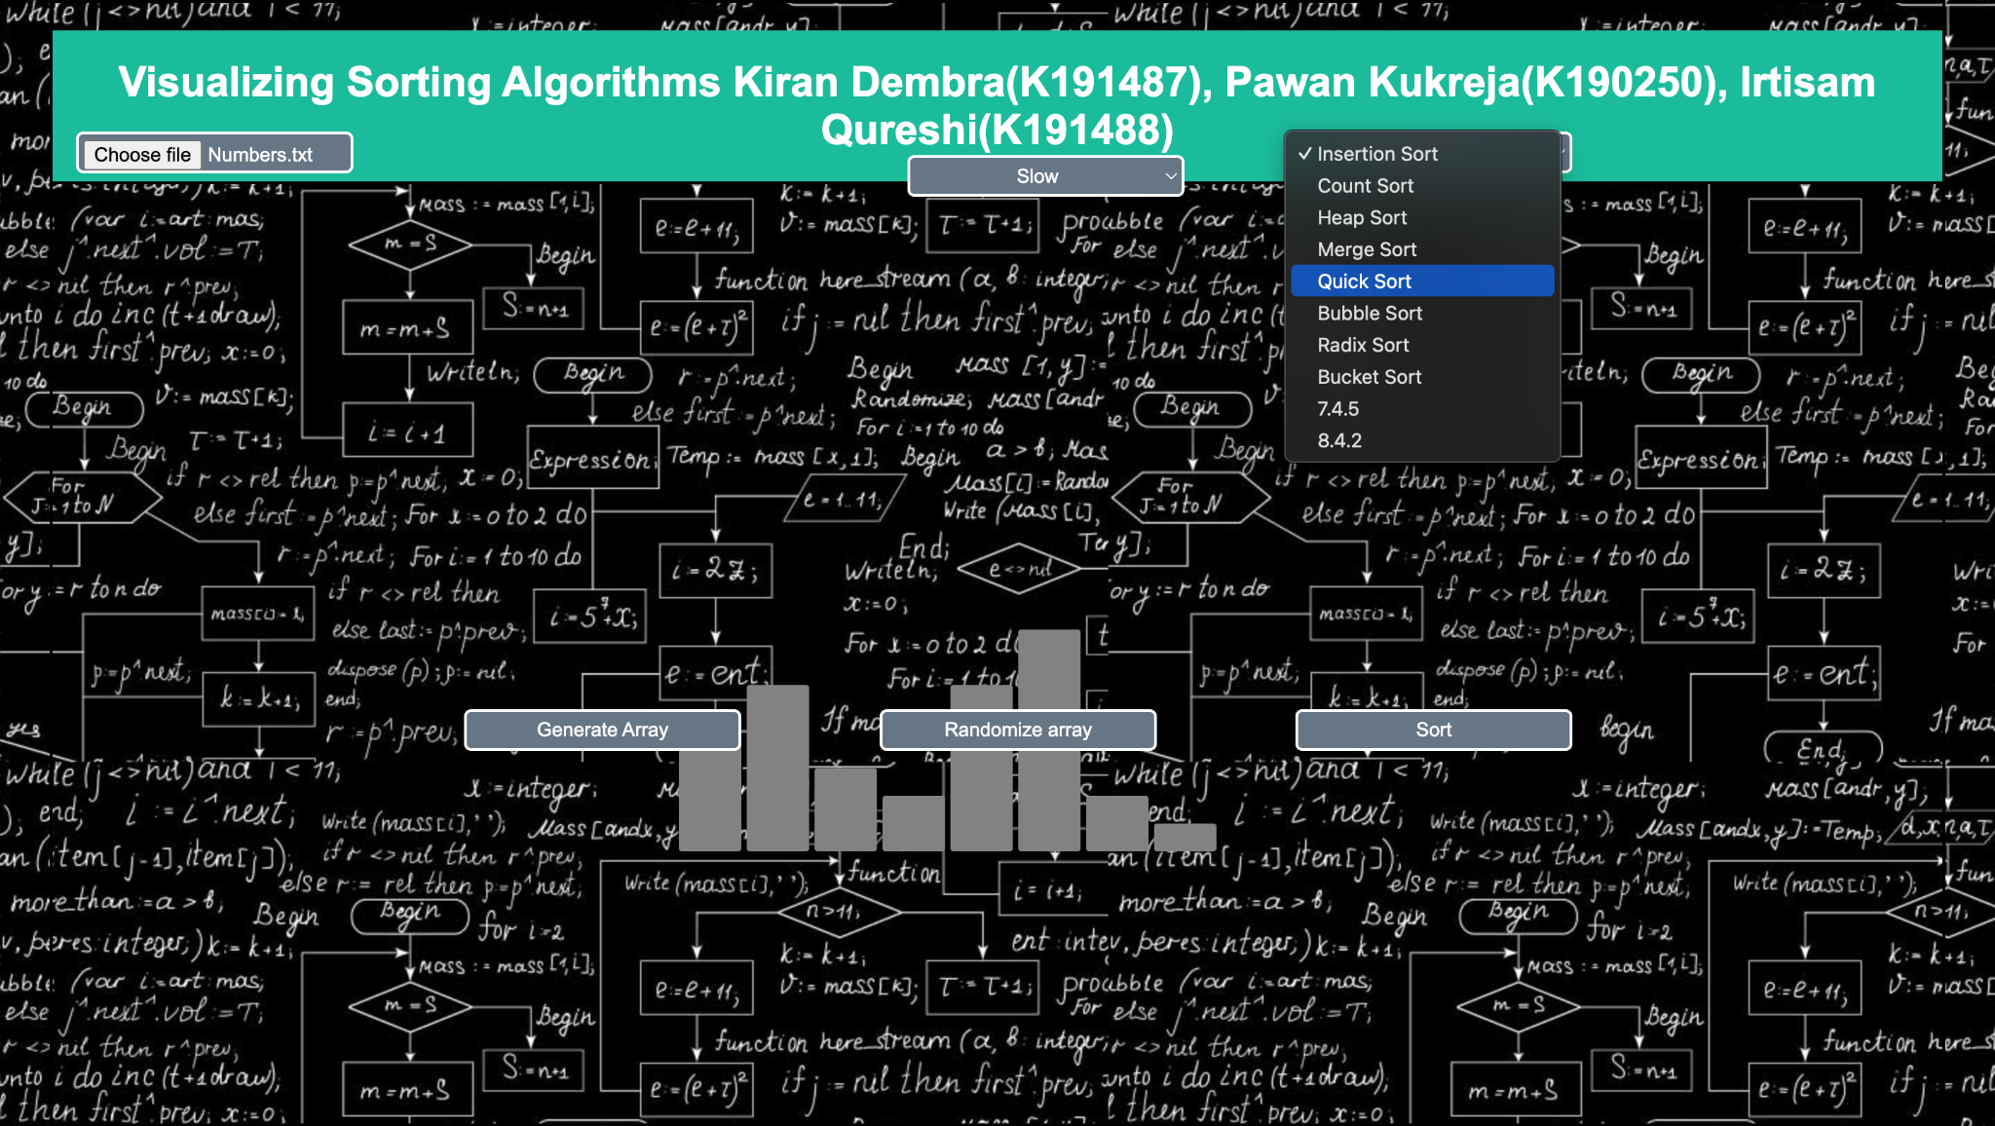

Step 6: Click on Sort to Perform sorting and finally the sorted array is displayed along with the time and space complexities**.**

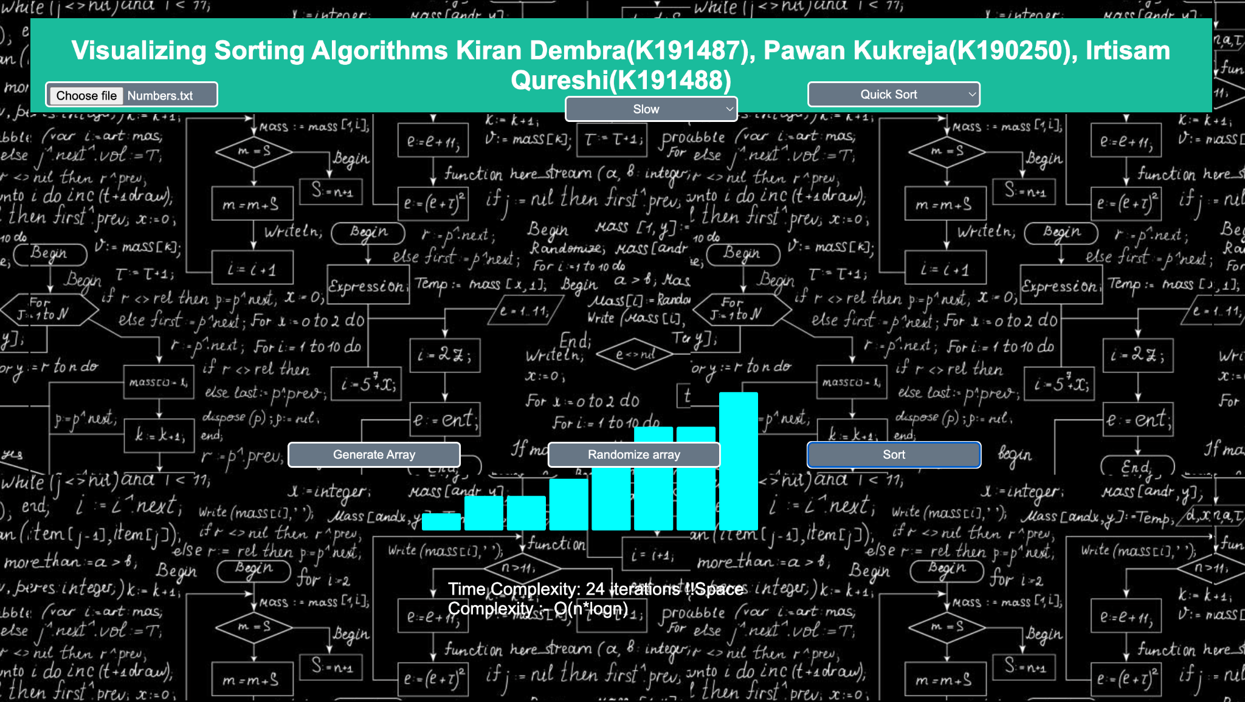

## **Results:** All the Sorting Technique will result in the Same output which can be scene in the following output

## **CONCLUSION**

There are a number of different algorithms for sorting from which we can choose in order to obtain a sorted result; nevertheless, the one that is most suitable is the one that minimises the amount of time and resources required for the computation. Although non-comparison-based algorithms have linear time complexities, comparison-based sorting algorithms, such as quick and merge sort, are the fastest comparison-based sorting algorithms. Non-comparison-based techniques, however, could result in enormous time complexities, which is not ideal.

## **REFERENCES:**

* GeeksForGeeks
* TutorialsPoint